**RP/ IPRC TUMBA**

**ACADEMIC YEAR: 2019-2020**

**Dept: RE / LEVEL 3/ SEMESTER 2**

**MODULE TITLE: AUTOMATION AND CONTROL SYSTEM**

**MODULE CODE: REN302**

**Friday 12th Nov, 2020**

**Assignment 7**

1. Consider the LCR electrical network shown in the figure below. Find the transfer function G(s) = Vo(s)/Vi(s).

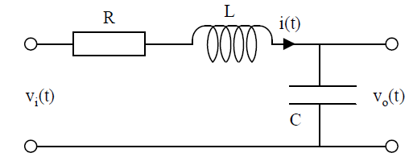

1. In the mechanical system shown in the figure below, m is the mass, k is the spring constant, b is the friction constant, u(t) is an external applied force and y(t) is the resulting displacement. Find the differential equation and the transfer function between the input U(s) and output Y(s).

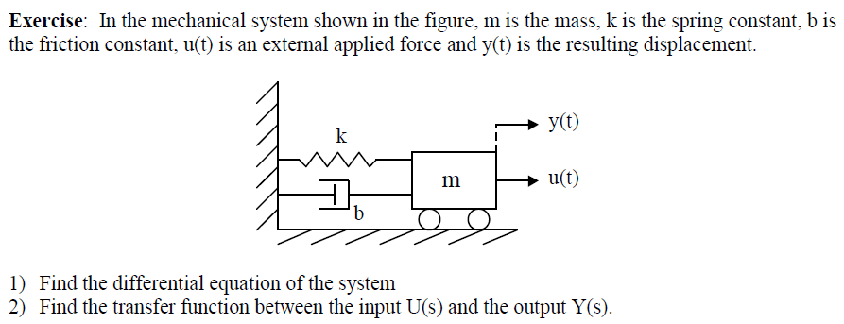

1. Consider the block diagram shown in the following figure. Reduce this block diagram using the block diagram reduction techniques.

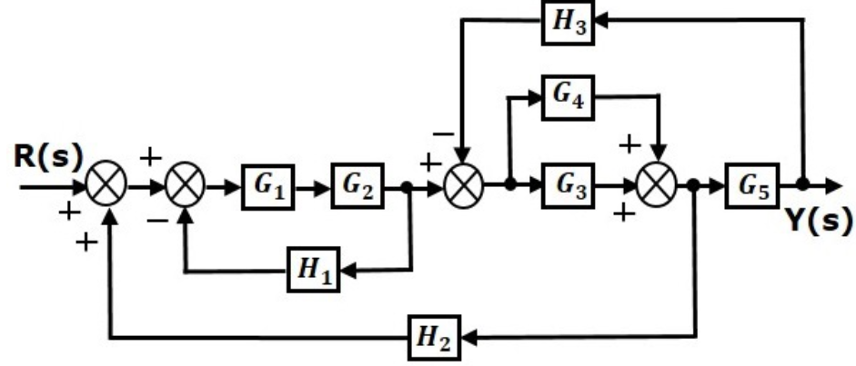

**NB.** To be submitted not later than: **Nov 29, 2020** before 11:59 PM

* Submission: **Hard copy to be submitted**
* Group Size: **4 students**
* If you need further clarifications please reach me to my email or Whatsap through: **jniyitegeka@iprctumba.rp.ac.rw /+250788973044**

**Stay safe and protected by washing your hands every time, avoiding shaking your friends or any physical contact!!!!**